***On my honor, I pledge that I have not violated the provisions of the NJIT Student Honor Code***

STUDENT TEAM No__**2**__

Name Signature

…Arsh Bhamla………… ___**ARSH BHAMLA~~___~~**_ …Pranay KC………….. _**_PRANAY RAJ KC_____** ..Shreedhar Rajendran. **__Shreedhar Rajendran—**

..Christopher Karkenny. __**Christopher Karkenny**_

Experiment performed on date _05/02 / 2025__

Report submitted on date ___05/07/2025______

Returned for corrections on date _________ Grade ______

Returned after corrections on date _________ Grade ______

**Introduction**

In this lab we will learn more about the basic properties and real-world uses of diodes such as rectifier and Zener diodes which let current flow in only one direction blocking it in the other which makes them essential for a lot of circuits. Our main goals of this lab are to check out the current-voltage (I-V) characteristics of both a rectifier diode and a Zener diode and compare the theoretical ideal diode with how actual diodes work and get hands-on experience with circuits like rectifiers, load line analysis, and clamp circuits through experiments such as forward- and reverse-biased. We will learn about the Zener breakdown effect and figure out the load line in diode circuits and test out clamp circuits used to protect sensitive electronics. We will use tools like protoboards, analog and digital meters, and oscilloscopes to get a solid understanding of how diodes work and why they’re so important.

**Procedure**

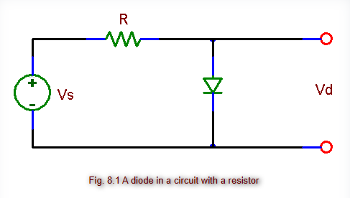

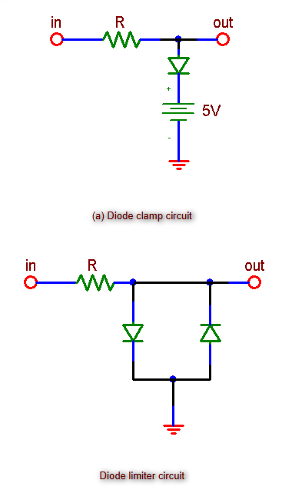

*Figure shown taken from* [*lab manual*](https://ecelabs.njit.edu/ece294/lab11.php)

**3.1 Measurements Of I-V Characteristics Of A Rectifier Diode**

We will start with the forward bias characteristic and set up a circuit with a rectifier diode in series with an incandescent lamp (to act as a current-limiting resistor) and a variable DC power supply. We will use a digital voltmeter to measure the diode voltage (Vd) and place an analog ammeter in series to measure the current (I) and set the power supply set to 0 V and slowly increase it in small increments like 0.1 V at first while recording (Vd) and (I) at each step and we will keep increasing the voltage until the current hits around 100 mA or the lamp starts to get noticeably bright. For the reverse bias characteristic, we will change up the circuit so that the positive terminal of the power supply connects to the cathode of the diode and the negative terminal connects to the anode through a high-value resistor (like 1 Mohm) and we will measure (Vd) using a digital voltmeter and (VR) (the voltage across the resistor) with another meter. We will then gradually apply reverse voltages from 1 V to 10 V and record (Vd) and (VR) at each step.

**3.2 Zener Diode**

We will set up a reverse bias circuit with a Zener diode and connect the cathode to the positive terminal of the power supply through a series resistor like an incandescent lamp or a 100 ohm resistor and place a digital voltmeter across the Zener diode to measure the Zener voltage (VZ) and connect an analog ammeter in series to measure the current (I). The power supply will start at 0 V and we will slowly increase the voltage taking note of (VZ) and (I) at each step until the current reaches around 20-30 mA, making sure the diode doesn’t get too hot.

**3.3 A Diode In A Circuit; The Load Line**

For part (a), we will set up a circuit using a variable DC power supply (Vs), a resistor (R), and a rectifier diode in series just like in Figure 8.1 and put a digital voltmeter across the resistor to measure (VR) and another one across the diode to measure (Vd). We will start the power supply at Vs = 0V and gradually increase the voltage in steps. For part (b) we will swap out the resistor for one with a lower value and repeat the same measurements.

**4. Diode Clamp Circuits**

For part (a) we will set up the diode clamp circuit shown in Figure 8.2a and use a resistor between the input and the node and connect a diode with its anode at the node and its cathode connected to +5 V and apply a sine wave to the input and use an oscilloscope to check out the output waveform. For part (b) we will assemble the diode limiter circuit with a resistor between the input and the output node and add two diodes in opposite directions between the output node and ground.

**Data and Calculations**

**3.1 Measurements Of I-V Characteristics Of A Rectifier Diode**

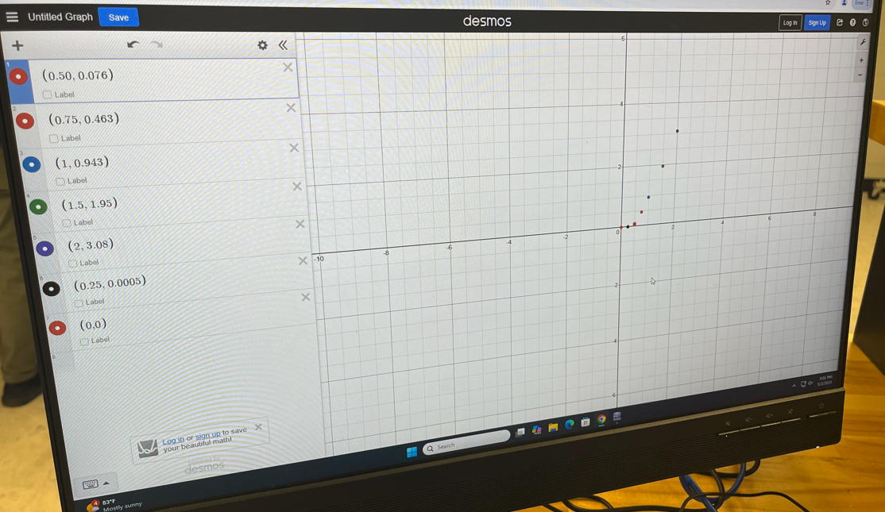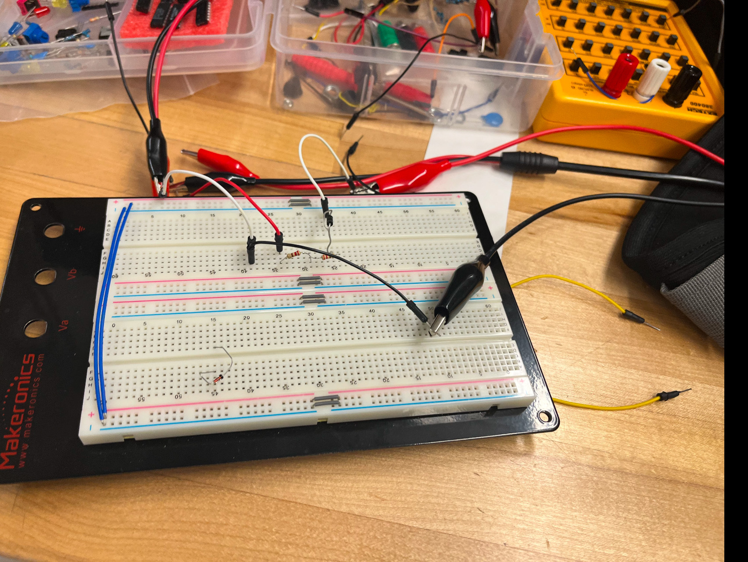

**3.2 Zener Diode**

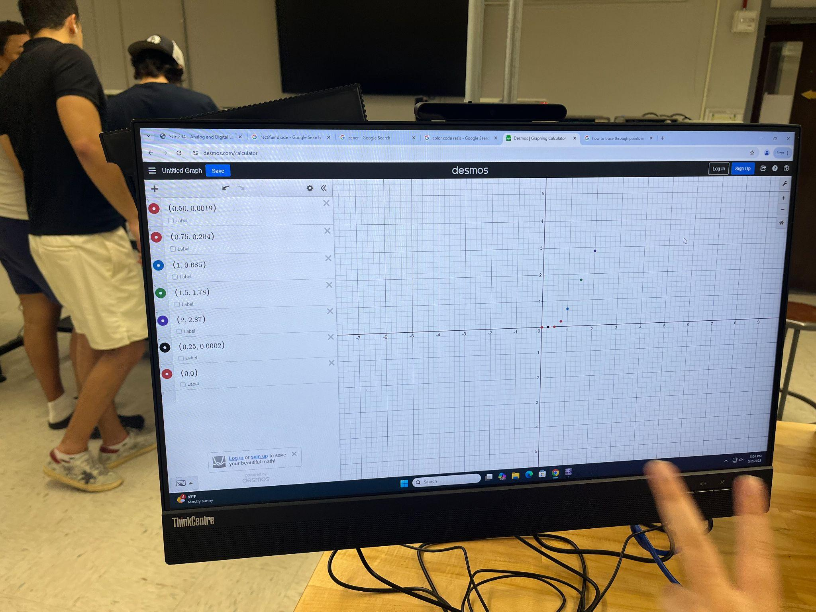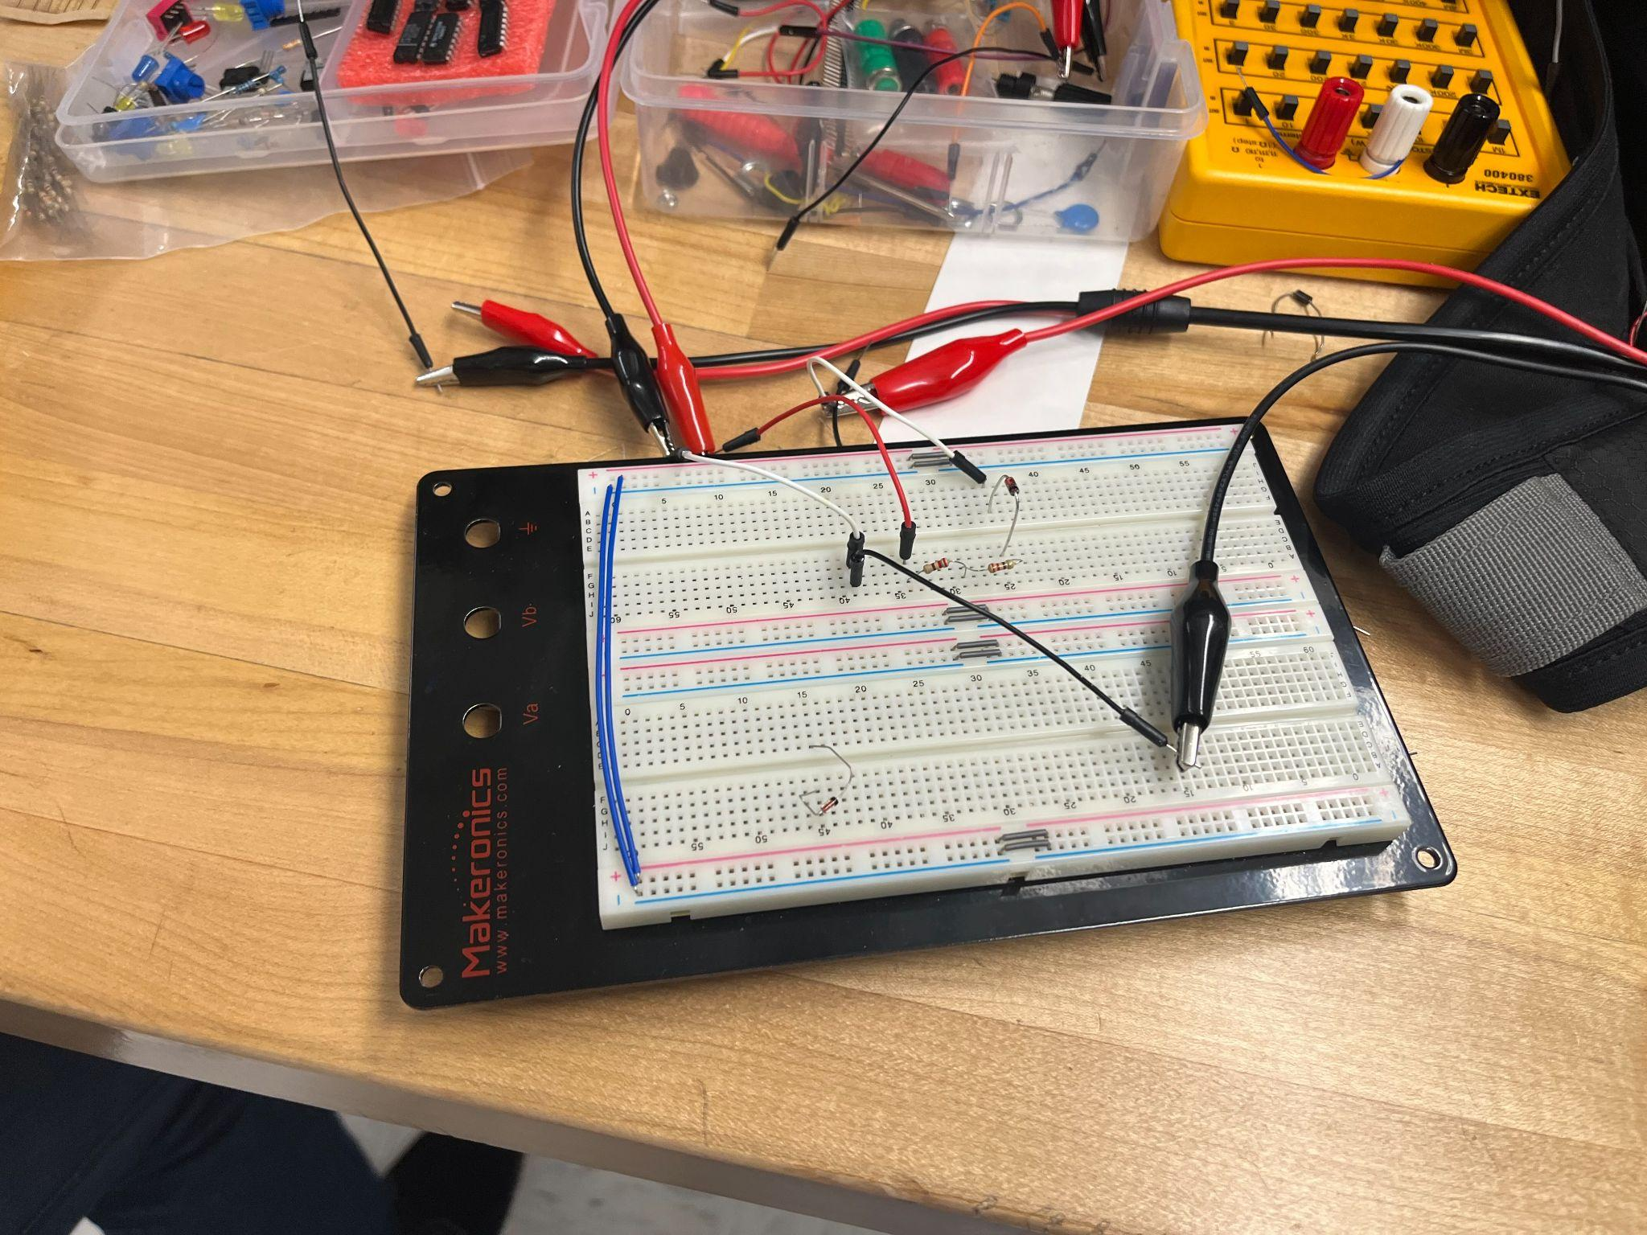

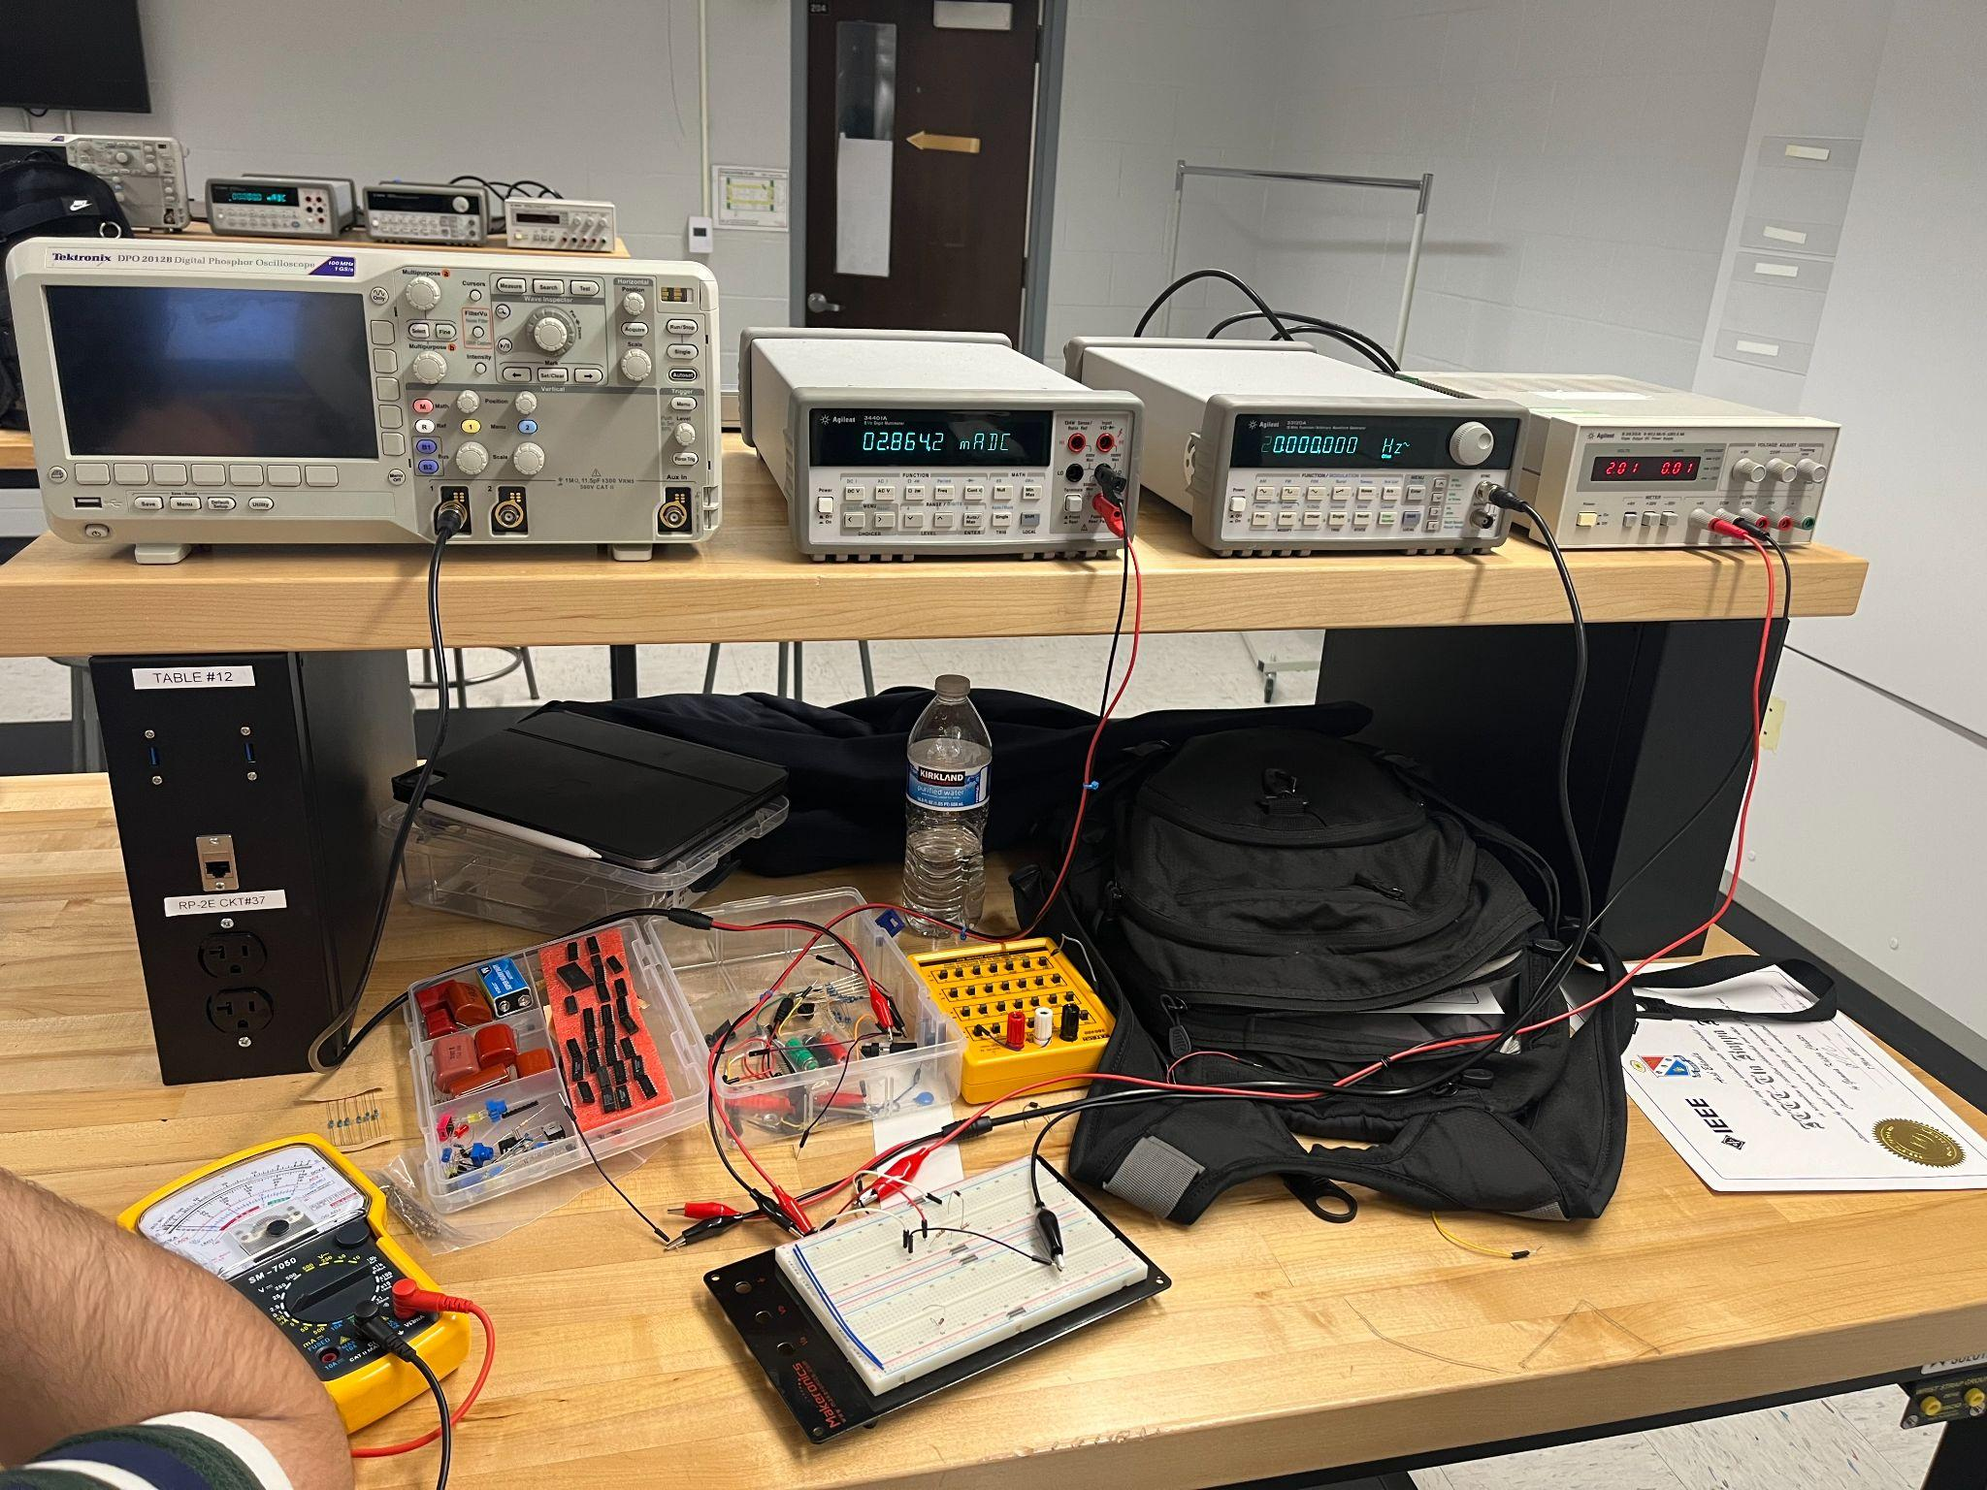

**3.3 A Diode In A Circuit; The Load Line**

1. For Vs=1.09V, VR = 0.565.6V, R=2kohm, VD=0.526V } i= 0.565.62k = 0.283mA
2. 100mA * 110 = 11V

P= (V)(100mA) = 0.25W

V=2.5V

Here, i=4.257V/110ohm =38.7mA

P=(V)(38.7mA) = 0.25W

V=6.46V

Power across resistor is less than 0.25W, so we meet safety power requirements

P=(4.257V)(31.7mA)

**4. Diode Clamp Circuits**

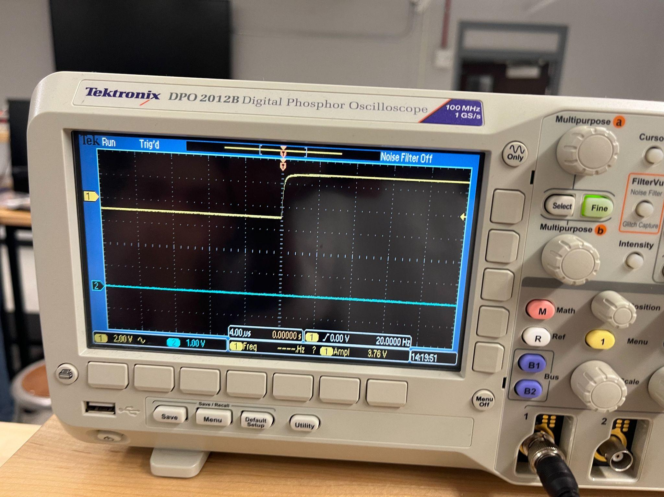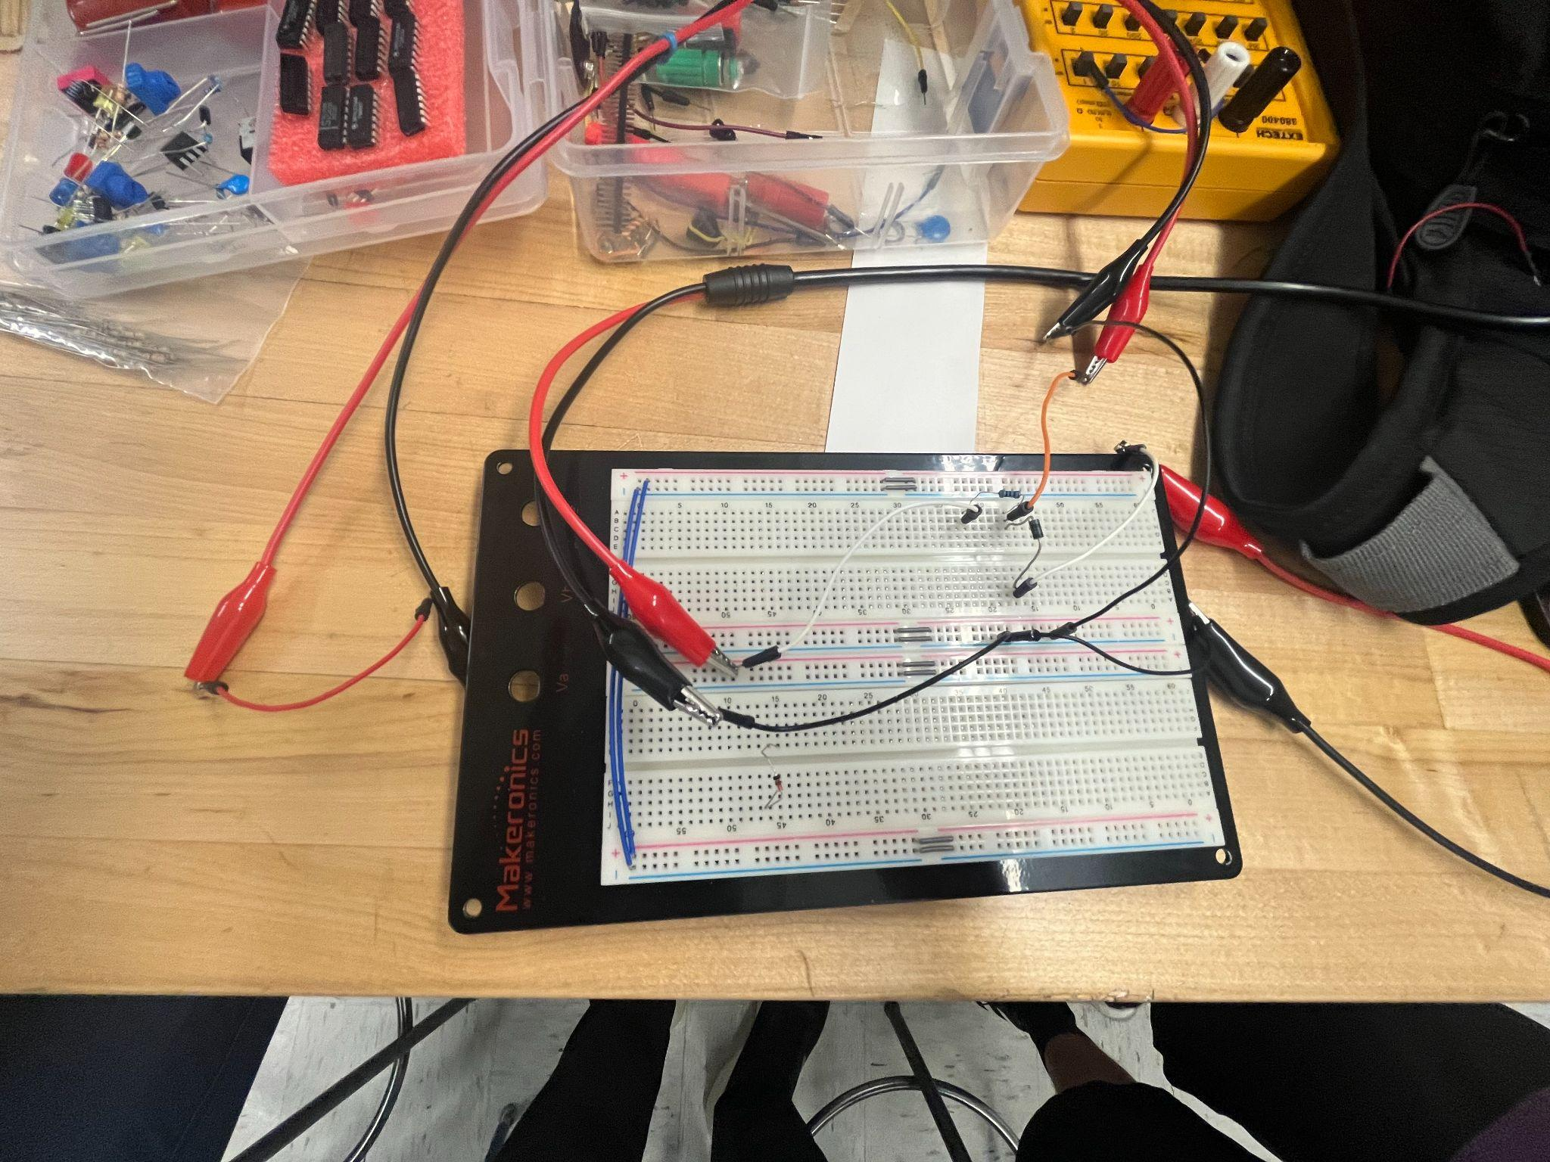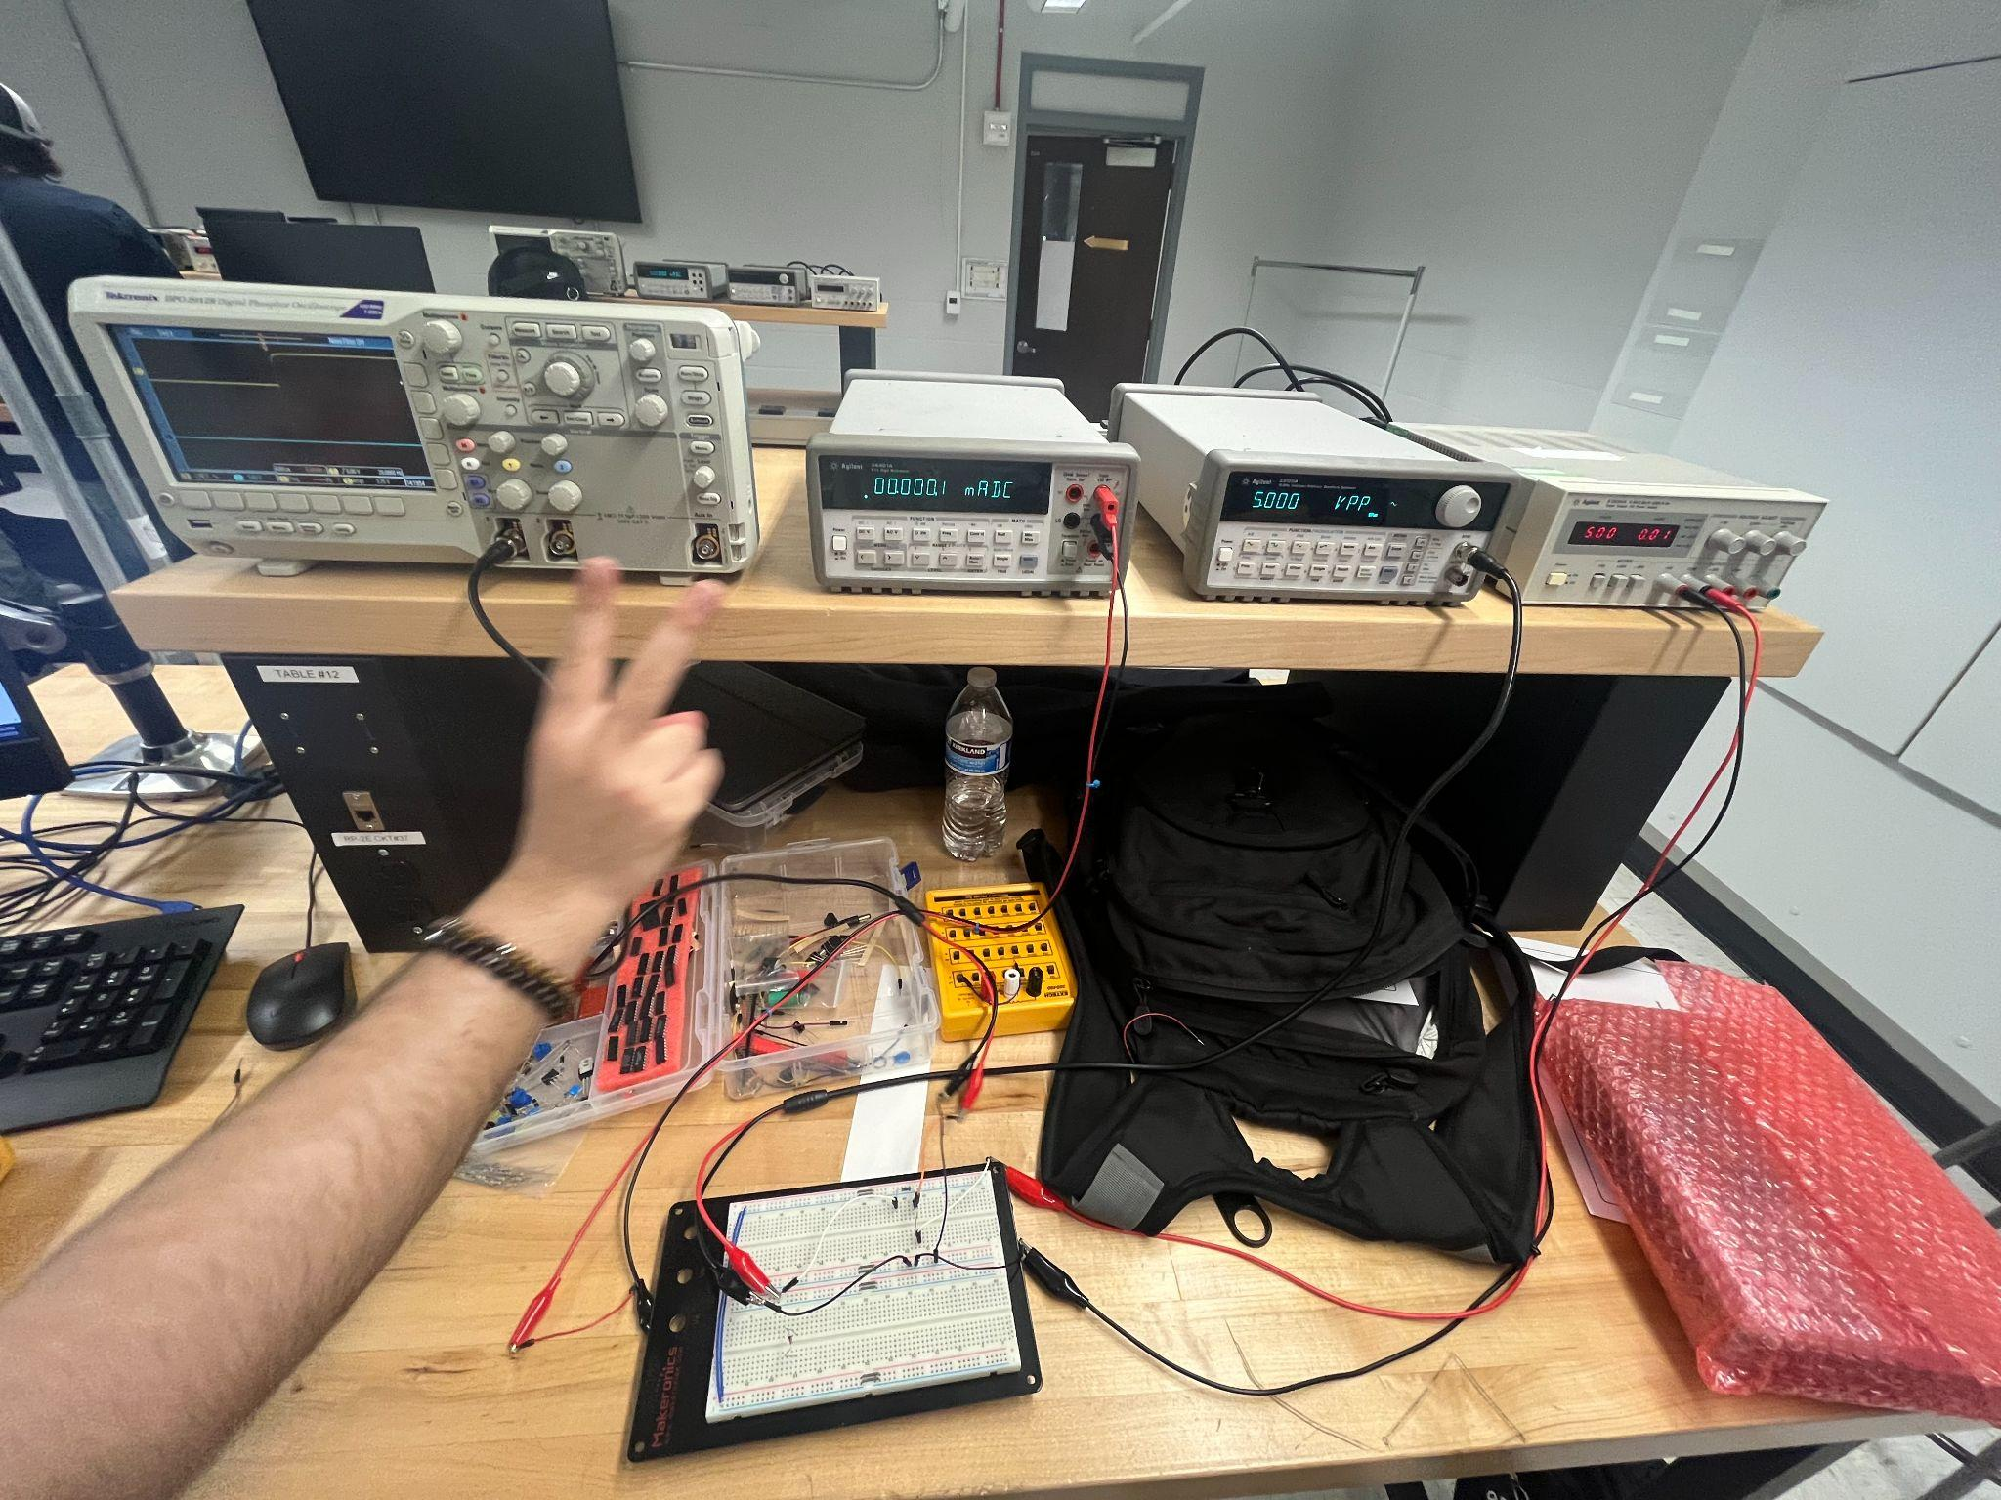

**Discussion**

The experiments in this lab gave us a solid look into how diodes behave under different biasing conditions and how they work in key electronic circuits as in forward bias the rectifier diode showed an exponential increase in current as the voltage went up and it also showed a clear threshold where significant current starts to flow. Under reverse bias, the diode blocked current effectively until it reached its breakdown voltage which showed us why it is essential for rectification and when testing the Zener diode in reverse bias, it showed its unique breakdown behavior. Load line analysis helped us understand how the diode’s properties interact with circuit components to determine the operating point and the clamp and limiter circuits highlighted the practical use of diodes in shaping waveforms and protecting circuits. These experiments reinforced the importance of knowing both the ideal diode models and real world factors, as well as how circuit design impacts performance.

**Conclusions**

This lab demonstrated the key properties and practical applications of diodes in electronic systems by confirming how rectifier and Zener diodes respond to forward and reverse biasing. Experiments with load lines and clamp circuits provided a better understanding of how diodes work in rectification, voltage regulation, and signal processing within larger circuits. While the majority of the results were consistent with our expectations, minor deviations demonstrated how temperature and component tolerances can affect performance, but this was not very noticeable. This lab expanded our understanding of diode functionality and stressed the significance of precise measurements and careful circuit design for dependable electrical performance.